**30-7-24 Java Lab Codes**

Program 1:

class Main

{

    public static void main(String[] args)

    {

        StringBuffer sb = new StringBuffer("Hello ");

        sb.append("Java");

        System.out.println(sb);

    }

}

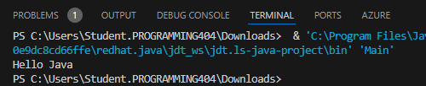

Program 2:

class Main

{

    public static void main(String[] args)

    {

        StringBuffer sb = new StringBuffer("Hello ");

        sb.insert(1,"Java");

        System.out.println(sb);

    }

}



Program 3:

class Main

{

    public static void main(String[] args)

    {

        StringBuffer sb = new StringBuffer("Hello ");

        sb.replace(1,3,"Java");

        System.out.println(sb);

    }

}

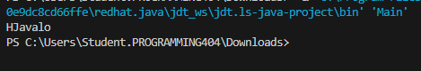

Program 4:

class Main

{

    public static void main(String[] args)

    {

        StringBuffer sb = new StringBuffer("Hello ");

        sb.delete(1,3);

        System.out.println(sb);

    }

}



Program 5:

class Main

{

    public static void main(String[] args)

    {

        StringBuffer sb = new StringBuffer("Hello ");

        sb.reverse();

        System.out.println(sb);

    }

}



Program 6:

class Main

{

    public static void main(String[] args)

    {

        StringBuffer sb = new StringBuffer(); //default 16

        sb.append("Hello");

        System.out.println(sb.capacity()); //still 16 as hello fits in

        sb.append("java is my favourute kanguage");// //capacity exceeded so formula is applied

        System.out.println(sb.capacity()); //now (16*2)+2 = 34  i.e(OldCapacity*2)+2

    }

}

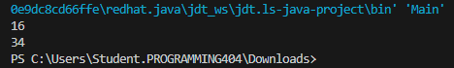

Program 7:

class Main

{

    public static void main(String[] args)

    {

        StringBuffer sb = new StringBuffer(); //default 16

        sb.append("Hello");

        System.out.println(sb.capacity()); //still 16 as hello fits in

        sb.append("java is my favourute kanguage");// //capacity exceeded so formula is applied

        System.out.println(sb.capacity()); //now (16*2)+2 = 34  i.e(OldCapacity*2)+2

        sb.ensureCapacity(10); //now no change

        System.out.println(sb.capacity()); //now 34

        sb.ensureCapacity(50); //now (34*2)+2

        System.out.println(sb.capacity()); //now 70

    }

}

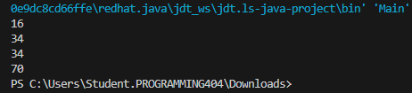

Program 8: (All Programs in StringBuilder)

class Main

{

    public static void main(String[] args)

    {

        StringBuilder sb = new StringBuilder("Hello ");

        sb.append("Java");

        System.out.println(sb);

        sb.insert(1,"java");

        System.out.println(sb);

        sb.replace(1,3,"java");

        System.out.println(sb);

        sb.delete(1,3);

        System.out.println(sb);

        sb.reverse();

        System.out.println(sb);

        System.out.println(sb.capacity()); //still 16 as hello fits in

        sb.append("java is my favourute kanguage");// //capacity exceeded so formula is applied

        System.out.println(sb.capacity()); //now (16*2)+2 = 34  i.e(OldCapacity*2)+2

        sb.ensureCapacity(10); //now no change

        System.out.println(sb.capacity()); //now 34

        sb.ensureCapacity(50); //now (34*2)+2

        System.out.println(sb.capacity()); //now 70

    }

}

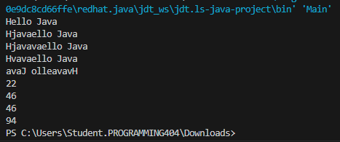

Lab Exercise:

import java.util.*;

class Main

{

    public static void main(String[] args)

    {

        System.out.println("number of elements: ");

        int n;

        Scanner sc = new Scanner(System.in);

        n=sc.nextInt();

        int arr[]= new int[n];

        for(int i=0;i<n;i++)

        {

            System.out.println("Enter element: ");

            arr[i]=sc.nextInt();

        }

        for(int i=0;i<n;i++)

        {

            for(int j=i+1;j<n;j++)

            {

                int temp = arr[i];

                arr[i] = arr[j];

                arr[j] = temp;

            }

        }

        System.out.println(arr[n-3]);

    }

}